**Detector Calibration Procedure**

27.2.2020

**Pulser Calibration**

If the value of the preamplifier “test input” capacitance is known, a pulsar can be used to give an absolute system calibration with a reasonable accuracy. The value of the test input capacitance varies between models of preamplifier, but is usually 1 pF.

However a more reliable method is to use a “charge terminator” of known capacitance, which is placed between the pulser and the preamp input (in place of the detector) (see fig.1):

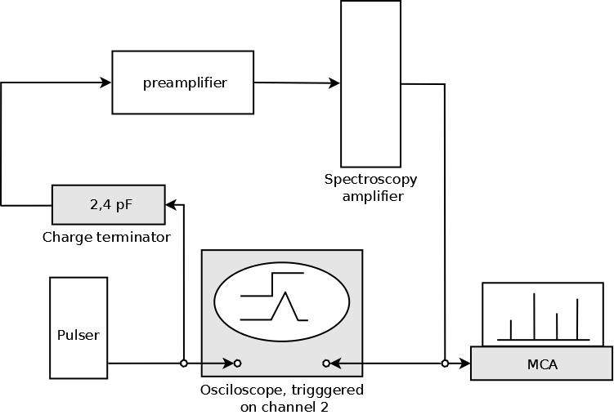

Fig.1. Scheme of the calibration of the spectroscopic system using charge terminator.

Used devices: Pulser – Precision Pulse generator ORTEC 419

Shaping amplifier – ORTEC 671

Digital oscilloscope – LeCroy WaveRunner 640Zi

MCA – Multi-channel analyzer ORTEC MCA Easy

Preamplifier Amptek 1GΩ

1. Connect the attenuated output from a precision pulser via T-piece to the charge terminator, and to the channel 1 of digital oscilloscope. The output of the charge terminator is connected to the detector input of the preamplifier (disconnecting any detector). Set the scope channel C1 on the DC 1MΩ coupling!

Whilst the calibration is carried out the scope and preamplifier must both be connected in the circuit, since the pulse amplitude measured on the scope depends on the correct loading of the pulser.

1. Connect the output of the spectroscopy amplifier via T-piece to channel 2 of the oscilloscope and to the multi-channel analyzer (MCA) input. Set the oscilloscope trigger to the channel C2 on the DC 50Ω coupling!

This provides a cleaner signal for the trigger, compared to the very small pulser signals.

1. Use averaging on the oscilloscope to improve the noise on the very small pulser signals. Take to care to adjust the trigger level and gain on channel 2 so that the oscilloscope always triggers cleanly on the amplifier output pulser, even at very small pulser amplitudes.
2. Acquire pulse height spectra on MCA for 8 – 10 different pulser amplitudes. For each amplitude, measure the **peak to peak height of the pulser signal** (in millivolts, from channel 1 of the oscilloscope using the scope cursors) versus the **MCA peak centroid** (in channel number). Depending on the system gain, cover the required range of pulsar signal amplitudes, making sure that you measured at very low pulser amplitude (e.g. down to 2 or 5 mV).

Gamma-ray calibration parameters: Amplifier: gain 500, Fine gain 0.5, shaping time 3μs, polarity NEG; Pulsar: Int. OSC, attenuation 2x2x5x10x ON, polarity POS, Normalize trimmer 0. Pulse height trimmer set in the interval 0.5-7 (2.7-40mV on the C1 channel of oscilloscope).

Alpha particle calibration parameters: Amplifier: gain 20, Fine gain 0.5, shaping time 3μs, polarity NEG; Pulsar: Int. OSC, attenuation 2x2x ON, polarity POS, Normalize trimmer 3. Pulse height trimmer set in the interval 0-10 (20-130mV on the C1 channel of oscilloscope).

Tabulate the data in the form:

|  |  |  |  |
| --- | --- | --- | --- |
| Peak centroid  (channel number) | Pulser signal amplitude (mV) | Pulser signal amplitude (C)1 | Pulser signal amplitude (keV)2 |
|  |  |  |  |

1the signal amplitude in Coulombs is calculated from the signal amplitude in mV knowing the value of the charge terminator capacitance *CQT*:



2the signal amplitude in keV is dependent on the *W* value of the detector. First calculate the number of electron-hole pairs produced (ehp):





**The accepted value for *CQT* = 2.4 pF,**

Therefore with *Vpulser* in mV, and *Epulser* in keV, then:





1. Plot a calibration graph of pulsar signal amplitude in keV (Y axis) vs. MCA peak centroid in channel number (X axis). A linear regression applied to this graph gives a gradient (keV/channel) and intercept (keV).

*Table1. Electron-hole pair creation energy (W) of some detector materials*

|  |  |
| --- | --- |
| **Material** | **W value (eV/ehp)** |
| Germanium | 3.0 |
| Silicon | 3.6 |
| Gallium Arsenide | 4.3 |
| Indium Phosphide | 4.2 |
| Cadmium Telluride | 4.5 |
| Cadmium Zinc Telluride | 4.5 – 5.0 |
| Silicon Carbide | 9 |
| Diamond | 13 |

The MCA offset (i.e. channel number at zero signal amplitude) is given by the intercept of the data on the X-axis.

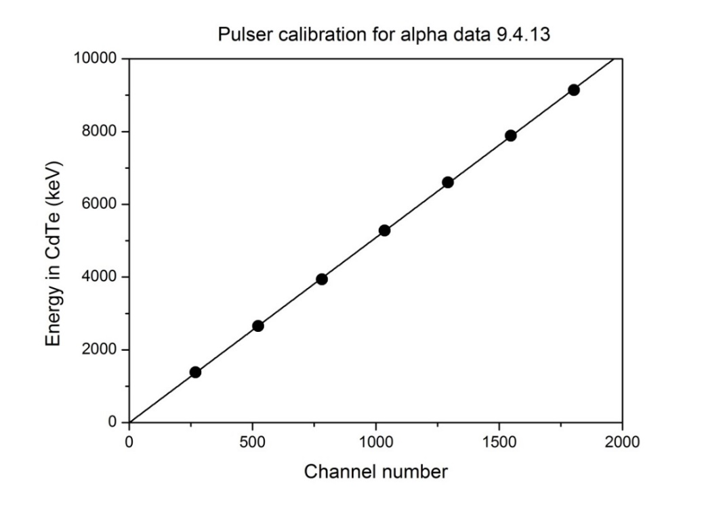

*Example of typical pulser calibration plot for CdTe detector (W = 4.5 eV/ehp), covering the energy range 0 – 10000 keV*

**Additional Calibration using a silicon detector**

As an additional check to the pulser calibration, replace your detector with a pre-characterized silicon detector, keeping all the other elements of the electronics and readout system identical.

Record a pulse height spectrum on the MCA for the silicon detector using a source that produces a signal in the required energy range (e.g. an 241Am alpha source at 5.49 MeV, or a 241Am gamma source at 59.6 keV). Alpha source measurements should be carried out in vacuum to avoid energy loss of the alpha particle in air.

The data point from the silicon detector should lie on the line of the pulsar calibration date in your calibration graph!